The New World Weapon Balance

Goals

* Ensure all weapons classes have distinct roles with strengths and weaknesses.
* Weapons should feel unique and handle different from each other even within a certain weapon class.
* No weapon should feel pointless and all weapons should have a purpose as some point in the game.
* All weapons should feel lethal and effective at its weapon class role.
* Weapons should feel authentic and comparable to their real world equivalent.

Balance Qualities

Damage (DAM) - simply the damage each individual bullet does. Changes based on distance from the target. Has a max and min value.

Rounds Per Minute - The amount of bullets fired within a minute, based on the real life value of the weapon in question.

Bullets To Kill (BTK) - Amount of bullets required to kill a standard human combatant. Used to calculate a starting point for Damage.

Time To Kill(TTK) - Time taken for a perfect kill(all bullets hit the target at the torso and score 100% of their potential damage)

Max Damage Range - Furthest distance from target where bullets still inflict maximum damage

Min Damage Range -Range from target at which bullets inflic minimum damage.

Mobility number (Mob) - A 1-10 number that signifies a weapon's mobility. A high Mobility number indicates a higher movement speed, faster reload and draw speed.

Standard Human Combatant (SHC) Damage Model

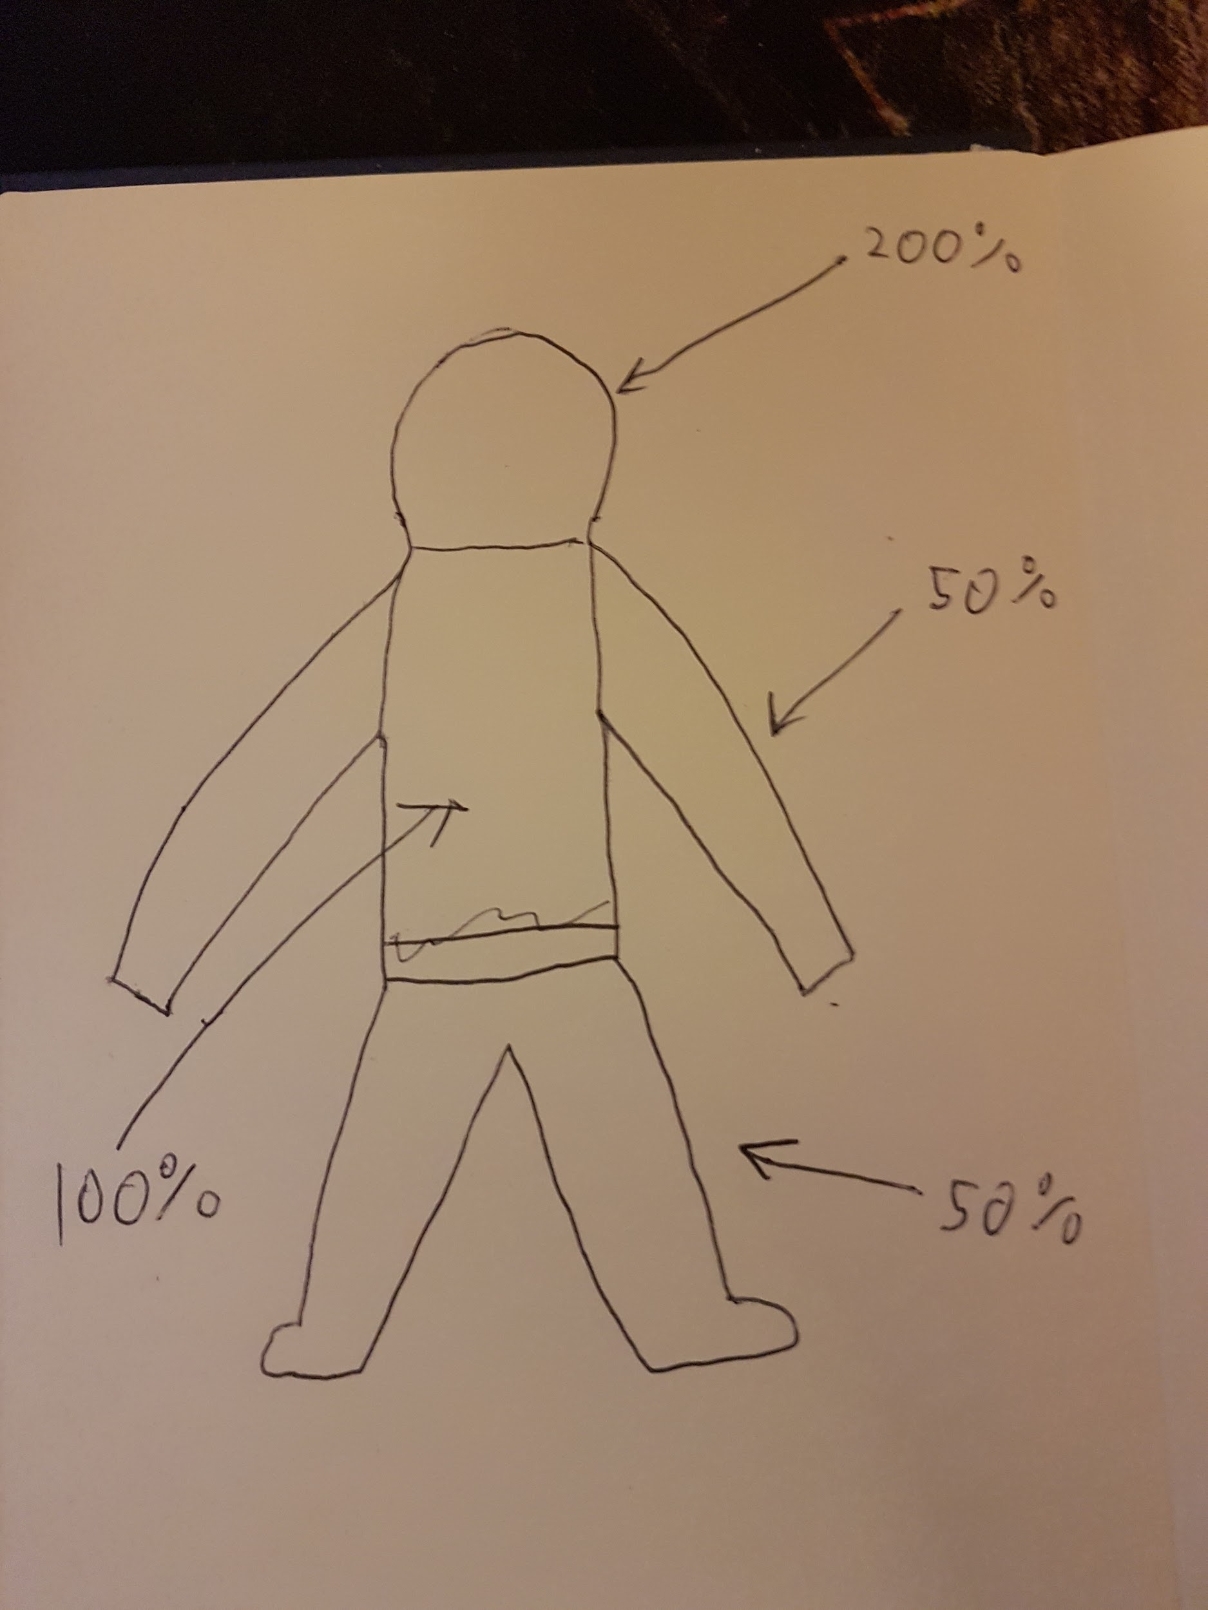

Rough Drawing of Damage Model

Bullets cause 100% of potential damage to the torso, 50% to extremities and 200% to head area.

Weapon Classes

Assault Rifle - A weapon class suited to medium range engagements. Effective in most situations however exells at none. Medium Mob number.

Carbine - Similar to the Assault Rifle category however a better suited to close to medium range engagements. Higher Mob than Assault Rifles with a shorter Max Dam and Min Dam range.

SMG - A weapon class suited to close range engagements. Rapid fire weapons with High mobility.

LMG - A weapon class suited to medium to long range engagements. Low Mob number, high capacity magazine (can fire a lot of bullets before reloading.

Shotguns - Suited best to extreme close to close range engagements. Medium to High Mob number. Separate independent damage model due to the pellet nature of shotgun shells

Marksman Rifles (Semi-Auto) - A weapon class suited to long range engagements. Medium to low Mob number.

Sniper Rifles (Bolt Action) - A weapon class suited to long to extreme long range engagements. Low ROF. Medium to low Mob number.

Pistols (semi-auto) - Secondary weapons used to quickly switch weapons to finish a target off. High ROF. High Mob. Best suited to close range combat. Low damage.

Auto-Pistols - V high RPM, best suited to close range engagements. High Mob.

Hand Cannons - Powerful handguns best suited to close to medium range. Low RPM, high damage, high mob.

Heavy Weapons - A class of weapons that behave very differently compared to the above classes.

Anti-Material Rifles - Extremely high damage sniper rifles. Very low Mob number. Can not be fired unless in cover or prone on the ground. Ammunition is rare.

Grenade Launcher - Explosive weapon. Medium Mob. Ammunition is rare.

Launchers - Explosive weapon. Must be fired from crouch and stationary. Low Mobility.

Method (for most weapon classes)

Due to the rapid fire nature of the weapons and the goal of lethal feeling weapons. The kill time is very quick. Currently its at about 0.45s on average although some weapons will kill faster at their effective range. This TTK is essential to ensure the weapons feel like deadly instruments and to ensure the player can go toe to toe with the large number of opponents they will encounter in The New World. Some enemies will of course have larger health pools and be tougher to take down however for standard opponents 0.45s is the region of TTK.

One quality of the weapon we don’t change is the rate of fire. This is set by the real world statistics of the weapons. For example the Kriss Vector has a RPM of 1200. This number cannot be changed otherwise we lose the authenticity of the weapon. Some weapons have a range of RPM, in this case it's up to our discretion on what number in the range we use for RPM. We will base this decision on numerous factors.

* Weapon Class- where does this weapon fit into the sandbox
* Range- At what range do we want this weapon to perform best. For example the L22 A3 has a range of 610-775 RPM, in this case we see that the L22 A3 is a carbine which is the middle ground between the assault rifle class and the SMG class. Therefore the weapon should have a longer range than the SMGs however to balance this it will have a slower RPM. The opposite is true of assault rifles. However this is not a fixed rule, as you can see in the balance sheet the L22 A3 has a lower RPM than the HK416 this is because i've decided that the L22 A3 should be an easy to handle medium range weapon.

Once we have the RPM we can move on to the Bullets to Kill, using the RPM we divide it by 60 to get the Rounds Per Second (RPS). Then we divide 1 by the RPS, this get us the time in seconds it takes to fire a single bullet. Then by dividing 0.45 by the time it takes to fire one bullet we can get a starting point.

Again using the L22 A3 as an example.

RPM of 700 divided by 60 is 11.7 bullets a second.

1 divided by 11.7 is 0.086

0.45(our starting point TTK) divided by 0.086 gives us 5.25 bullets a second.

Using this 5.25 as a basis we can now decide how we want the weapon to perform.

Now 5.25 bullets can't exist so we round it down to 5 and multiply it with 0.086 to give us the actual TTK in this case 0.43s.

We can now work out the Max damage the weapon inflicts with the simple calculation of the enemy hit points (100) divided by number of bullets which for the L22 A3 gives us 20. However the HK416 has the same Max damage number and a higher RPM which somewhat diminishes the point of the L22 A3 so to remedy this we up the Max damage to 23 which still gives it 5 BTK and gives it a little edge over the HK416 at its optimum range.

However due to the L22 A3 being a carbine its range is shorter than that of the HK416 so its damage dropoff should reflect that. So we drop the damage to 16, this ups the BTK to 7 to ensure the HK416 outperforms the L22 A3 at range.

Now we have to work out what the effective range is.

Using the weapon classes and what role they play is a good starting point.

The L22 A3 is a carbine therefore it should outperform assault rifles and LMGs at closer range however SMGs and pistols should outperform it. Equally assault rifles and LMG should outperform the L22 A3 at range and the L22 A3 should outperform SMG and pistols at range.

So using these relationships between the classes we can work out a rough Max Damage and Min Damage range.

For the L22 A3 this results in a Max Damage range of 23, this means it has a longer Max Dam range than the HK416 however the Min Damage range, which is 50, is shorter than that of the HK416 ensuring that in closer ranges the L22 A3 out damages the HK416 but at longer ranges loses out.

The Mobility number is simply a reflection on how quick the weapon should reload, how fast the player should move with the weapon equipped and how quick the weapon is to draw. It's just a representation of how fast the weapon should function as a whole. The weapons are assigned this number based on the size, weight and ammo capacity of the real world weapons.

For the L22 A3 the Mob number is 6 due to the fact that it is a lighter weight weapon (so a high mob number) but a bullpup design (the magazine is located behind the trigger) with in real life makes the weapon a little harder to reload therefore lowering the mob number.